Means

The Chinese goverment labels you as religious extremist (or maybe terrorist) if you are either an ethnic muslim or have your own opinion and reject being brain washed.

If the Chinese goverment labeled you as extremist (or terrorist) then you will be illegally sent to a concentration camp for re-education or will be illegally sentenced to imprisonment.

In the concentration camp the Chinese goverment will forcibly transform your mind so you will learn there to follow the party line by being constantly psychologically and physically tortured. In the extreme case you will not survive, only your body will be released, released to your relatives to be buried.

Labeled as extremist if

The Chinese goverment labels you as religious extremist (or maybe a terrorist) if:

* you have a large family
* you pray and/or have Quran
* you are a woman and wear face covering burqa
* you are a man and grow long beard
* your minor participates in religous activities
* you give your child an irregular name
* you are thinking (reject being brainwashed, disagree with such labeling or just listen to such talks)

You have a large family

Such as the 34-year-old Patem, whose „crime for which she was detained, was a violation of family planning policy, or put simply, having too many children. Under the countrywide policy, rural families in Xinjiang are limited to three children. Patem had four.”

*CNN: Watched,judged,detained (2020):* <https://edition.cnn.com/interactive/2020/02/asia/xinjiang-china-karakax-document-intl-hnk/>

According to the Xinjiang De-extremification Law it is labeled extremism interfering or undermining family planning policy, put simply having too many children.

*Unofficial translation of the law:* <https://www.chinalawtranslate.com/en/decision-to-revise-the-xinjiang-uighur-autonomous-region-regulation-on-de-extremification/>

You pray and/or have Quran

Such as Renagul Gheni, a mother of two, who was detained for 2 years in an internment camp, then sentenced for 7 years because praying after her father passed away. She was also given extra 10 years for havig a Quran.

*Personal testimony of Kalbinur Gheni, sister of Renagul:* <https://twitter.com/Qelbinur10/status/1334299224712876032>

According to the Religious Affairs Regulation, collective religious activities should be held at religious activity sites.

*Unofficial translation of the the Religious Affairs Regulation:* <https://www.chinalawtranslate.com/en/religious-affairs-regulations-2017/>

According to the Xinjiang De-Extremification Law it is extremism to interfer with activities such as others' weddings and funerals or inheritance.

*Unofficial translation of the Xinjiang De-extrimification law:* <https://www.chinalawtranslate.com/en/decision-to-revise-the-xinjiang-uighur-autonomous-region-regulation-on-de-extremification/>

You are a woman and wear a face covering burqa

„Another detainee is recorded as having refused to take off her face veil for years. She went to Saudi Arabia with her husband twice, she insisted on wearing a face veil … with the excuse of rhinitis (allergies), despite committee cadres asking her (not) to do so several times. The woman took off her veil in 2016, but was still sent to a detention center for being a potential threat.”

*Leaked Chinese goverment papers as reported by CNN:* <https://edition.cnn.com/interactive/2020/02/asia/xinjiang-china-karakax-document-intl-hnk/>

Wearing a face covering burqa is religious extremism according to the Xinjiang De-Extremification Law.

*Unofficial translation of the Xinjiang De-extrimification law:* <https://www.chinalawtranslate.com/en/decision-to-revise-the-xinjiang-uighur-autonomous-region-regulation-on-de-extremification/>

You are a man and grow a long beard

According to the Xinjiang De-Extremification Law it spreads religious fanaticism if someone grows irregular beard, put simply having a long beard.

*Unofficial translation of the law:* <https://www.chinalawtranslate.com/en/decision-to-revise-the-xinjiang-uighur-autonomous-region-regulation-on-de-extremification/>

Your minor participates in religious activities

You are labeled extremist (or maybe a terrorist) if your minor participates in religious activities or in any way you help minors participating in religious activities.

According to the Xinjiang Counter-Terrorism Law it is labeled extremism organizing, forcing, instigating, encouraging or enticing minors to participate in religious activities, put simply passing on religious beliefs to the next generation.

*Unofficial translation of the law:* <https://www.chinalawtranslate.com/en/xinjiang-implementing-measures-for-the-p-r-c-counter-terrorism-law-2018>

Note also that Xinjiang, Implementation Measures of the Law on the Protection of Minors, already baned religion for minors back in 1993 (!). Article 14 says: "parents and legal guardians may not allow minors to participate in religious activities"

*Official source:* [*http://www.npc.gov.cn/zgrdw/npc/zfjc/wcnzfjc/2008-08/05/content_1440992.htm*](http://www.npc.gov.cn/zgrdw/npc/zfjc/wcnzfjc/2008-08/05/content_1440992.htm)

You give your child an „irregular” name

As RFA reported: „Islam, Quran, Mecca, Jihad, Imam, Saddam, Hajj, and Medina are among dozens of baby names banned.”

They interviewed an employee at a police station in Urumqi, who confirmed: „Overly religious names are banned, and that any babies registered with such names would be barred from the hukou household registration system that gives access to health care and education.”

When asked if names of Islamic scholars were acceptable, the employee replied: "Get him to change it; it's the sort of thing that [could be regarded as] promoting terror and evil cults."

When asked if Yultuzay, a reference to the star and moon symbol of the Islamic faith, was acceptable, he said: "Actually the star and moon are a pagan symbol."

He also added: "They have received training in this sort of thing over here [in Xinjiang] so they're the experts [on what is allowed],".

*RFA: China Bans 'Extreme' Islamic Baby Names Among Xinjiang's Uyghurs (2017):* [*https://www.rfa.org/english/news/uyghur/names-04202017093324.html*](https://www.rfa.org/english/news/uyghur/names-04202017093324.html)

According to the Xinjiang De-Extremification Law, giving an irregular name spreads religious fanaticism.

*Unofficial translation of the law:* <https://www.chinalawtranslate.com/en/decision-to-revise-the-xinjiang-uighur-autonomous-region-regulation-on-de-extremification/>

You advocate religious practices and avoiding secular companies

Such as the man “who urged his co-workers to avoid pornography, to pray and to avoid socializing with those who don’t pray, including Han Chinese kafirs (kafir is an Arabic word meaning infidel or nonbeliever). The witnesses to the alleged offenses were co-workers, with Uighur names, with whom he had spoken. He received a charge of incitement of extreme thoughts, ethnic hatred and ethnic discrimination. He was sentenced to 10 years in prison.”

International Consortium of Investigative Journalists: Exposed: China’s Operating Manuals for Mass Internment and Arrest by Algorithm (2019): <https://www.icij.org/investigations/china-cables/exposed-chinas-operating-manuals-for-mass-internment-and-arrest-by-algorithm/>

According to the Xinjiang De-Extremification Law, it is labeled extremism

* Advocating or spreading extremist thinking
* Interfering with others from having communication, exchanges, mixing with, or living together, with persons of other ethnicities or other faiths; or driving persons of other ethnicities or faiths to leave their homes

*Unofficial translation of the law:* <https://www.chinalawtranslate.com/en/decision-to-revise-the-xinjiang-uighur-autonomous-region-regulation-on-de-extremification/>

You are thinking

You are labeled as extremist if you reject watching TV or listening radio, put simply reject being brainwashed. Since:

According to the Xinjiang De-Extremification Law:

* It is labeled extremism interfering with normal cultural and recreational activities, rejecting or refusing public goods and services such as radio and television. And at the meantime:
* The mass media and new media shall innovate as to medium and methods, to use multiple channels to carry out de-extremification publicity activities aimed at different targets and audiences.

*Unofficial translation of the law:* <https://www.chinalawtranslate.com/en/decision-to-revise-the-xinjiang-uighur-autonomous-region-regulation-on-de-extremification/>

Even if you are none of the above, you are an extremist (or maybe a terrorist), if you disagree with the labeling or you listen to such talk. Since:

According to the Xinjiang De-Extremification Law the following is labeled extremism:

* Advocating or spreading extremist thinking
* Publishing, printing, distributing, selling, producing, downloading, storing, reproducing, accessing, copying, or possessing articles, publications, audio or video with extremification content;

*Unofficial translation of the law:* <https://www.chinalawtranslate.com/en/decision-to-revise-the-xinjiang-uighur-autonomous-region-regulation-on-de-extremification/>

According to the Xinjiang Counter-Terrorism Law someone pursues criminal responsibility who

* produces, distributes or illegally possesses publications, audio or video data or other articles that advocate terrorism or extremism

*Unofficial translation of the law:* <https://www.chinalawtranslate.com/en/xinjiang-implementing-measures-for-the-p-r-c-counter-terrorism-law-2018>

Forced re-education in concentration camps

The Chinese government holds an estimated 1-3 million Uighurs, other ethnic and Muslim minorities in Xinjiang concentration camps. These camps were designed to re-educate ethnic citizens in order to destroy their religious identity or ethnic identity, or both, to transform them into a homogeneous, mindless, and therefore manageable mass.

To achieve the goal of forced mind-transformation, the Chinese government is using constant psychological and physichal torture against those illegally detained in the camps.

The Chinese goverment forcibly teaches detainees to follow the party line, such as to day by day praise Xi Jinping, sing party songs and learn Mandarin. They constantly tortures detainees both psychologically and physically, such as constantly humiliating religious people, brutally beating men and women, gang-raping women and forcibly sterilizing them.

The Chinese goverment maintains a system of constant terror in Xinjiang which then effects not just detainees but their relatives, friends and even the Uyghur diaspora by closing them into the prison of anxciety.

Illegal detaiment for no reason

The 5-year-old Hediche Ablimit is one of the over 10,000 victims registered in the Xinjiang Victims Database. She is 4774 in the database. 4473 is her brother Yunus. 4472 is her brother Imran. 4771 is her sister Rehime. 4702 is her mother, Horiyet.

|  |  |
| --- | --- |
| Hediche Ablimit | *Hediche Ablimit’s page in the Xinjian Victim Database:* <https://mail.shahit.biz/eng/viewentry.php?entryno=4774> |

Here is her story:

Hediche’s father, Ablimit Tursun, after his brother’s detention in 2017, fled China and now lives in Belgium. Her father tried to get a family reunification visa for the family. As the Belgian embassy asked them for a medical certificate, they had to travel to Beijing. Although her mother was afraid to leave Xinjiang because it was only possible with permission, there was no choice, otherwise the application would have expired.

They arrived in Beijing on the night of May 26, 2019. Shortly after they took their seats in the hotel, police officers arrived to interrogate them, inquiring, among other things, about the purpose of their stay. His mother reported on the purpose of the visit, a request from the Belgian embassy.

The next day, May 27, all the necessary medical and other certificates required for the application were obtained.

On the third day, May 28, they went to the embassy in possession of the certificates. There, embassy officials informed her mother that the application could take up to three months to process, so she was advised to return to Urumqi, the capital of Xinjiang. This made her mother extremely nervous, fearing that if they returned to Xinjiang, they would have serious problems. She therefore asked to remain at the embassy for the duration of the proceedings, while also asking for their protection. The embassy threatened them to call the police if they did not leave. The former also happened, with the embassy calling on Beijing police to remove the family. Police arrived at 4 a.m. and forcibly removed them from the embassy, ​​forcing them to return to their hotel, where the Urumqi police were already waiting for them.

On the fourth and fifth days, May 29 and 30, nothing extraordinary happened. They were able to talk to her father without hindrance.

On the sixth day, May 31, while video chatting with her father, 4 police officers broke into their room and took her mother’s phone.

They were not heard from for 18 days thereafter.

When Belgium would have sent two diplomats to find them, the relationship was suddenly re-established. Their father asked what happened, but her mother refused to give details. All she told him was that the district committee visits them daily, taking pictures to prove they were home. She also said police had asked her to sign a document admitting she had committed a crime against national security, but his mother refused.

Several months later, Ablimit Tursun, Hediche Ablimit’s father, now working in Belgium, still cannot contact his family after they were sent back to Xinjiang. Someone deleted his wife's WeChat.

*Uighur Family Spends More Than A Year Imprisoned In Own Home In China:* <https://www.npr.org/2020/07/13/890558029/uighur-family-spends-more-than-a-year-imprisoned-in-own-home-in-china>

Inhuman conditions

Qelbinur Sidik worked as a teacher in two camps, where she claims she saw starvation rations and unsanitary and humiliating conditions, including limited access to bathrooms and water. She also heard the screams of tortured prisoners and witnessed at least one inmate being carried out dead.

„There were almost 20 people in a room of 16 square meters. There were cameras in their rooms, too, and also in the corridor. Each room had a plastic bucket for a toilet. Every prisoner was given two minutes a day to use the toilet, and the bucket was emptied only once a day.”

*The Guardian: Uighur Muslim teacher tells of forced sterilisation in Xinjiang:*

<https://www.theguardian.com/world/2020/sep/04/muslim-minority-teacher-50-tells-of-forced-sterilisation-in-xinjiang-china>

Continuous humiliation

I’d thought the theory classes would bring us a bit of relief from the physical training, but they were even worse. The teacher was always watching us, and slapped us every chance she got. One day, one of my classmates, a woman in her 60s, shut her eyes, surely from exhaustion or fear. The teacher gave her a brutal slap. “Think I don’t see you praying? You’ll be punished!” The guards dragged her violently from the room. An hour later, she came back with something she had written: her self-criticism. The teacher made her read it out loud to us. She obeyed, ashen-faced, then sat down again. All she’d done was shut her eyes.

*The Guardian: 'Our souls are dead': how I survived a Chinese 're-education' camp for Uighurs*

<https://www.theguardian.com/world/2021/jan/12/uighur-xinjiang-re-education-camp-china-gulbahar-haitiwaji>

Gang rapes

Ms Sautybay said women were systematically raped and that she was forced to watch a woman be repeatedly assaulted.

“The policemen ordered her to disrobe and simply raped her one after the other, in front of everyone,” she told*.*

*“*While they were raping her they checked to see how we were reacting. People who turned their head or closed their eyes, and those who looked angry or shocked, were taken away and we never saw them again.

“It was awful. I will never forget the feeling of helplessness, of not being able to help her.”

*INDEPENDENT: Prisoners in China’s Xinjiang concentration camps subjected to gang rape and medical experiments, former detainee says:*

<https://www.independent.co.uk/news/world/asia/china-xinjiang-uighur-muslim-detention-camps-xi-jinping-persecution-a9165896.html>

Forced sterilization

In the “transformation-through-education” camps, life and death do not mean the same thing as they do elsewhere. A hundred times over I thought, when the footfalls of guards woke us in the night, that our time had come to be executed. When a hand viciously pushed clippers across my skull, and other hands snatched away the tufts of hair that fell on my shoulders, I shut my eyes, blurred with tears, thinking my end was near, that I was being readied for the scaffold, the electric chair, drowning. Death lurked in every corner. When the nurses grabbed my arm to “vaccinate” me, I thought they were poisoning me. In reality, they were sterilising us. That was when I understood the method of the camps, the strategy being implemented: not to kill us in cold blood, but to make us slowly disappear. So slowly that no one would notice.

*The Guardian: 'Our souls are dead': how I survived a Chinese 're-education' camp for Uighurs*

<https://www.theguardian.com/world/2021/jan/12/uighur-xinjiang-re-education-camp-china-gulbahar-haitiwaji>

No information about the where, why and what

Kalbinur Gheni wants her sister, Renagul Gheni to be released. She was detained in 2018 into a Chinese concentration camp then sentenced to 17 years for praying and having a Quran. Since then she never heard about her. Renagul's 2 sons are waiting her back, too.

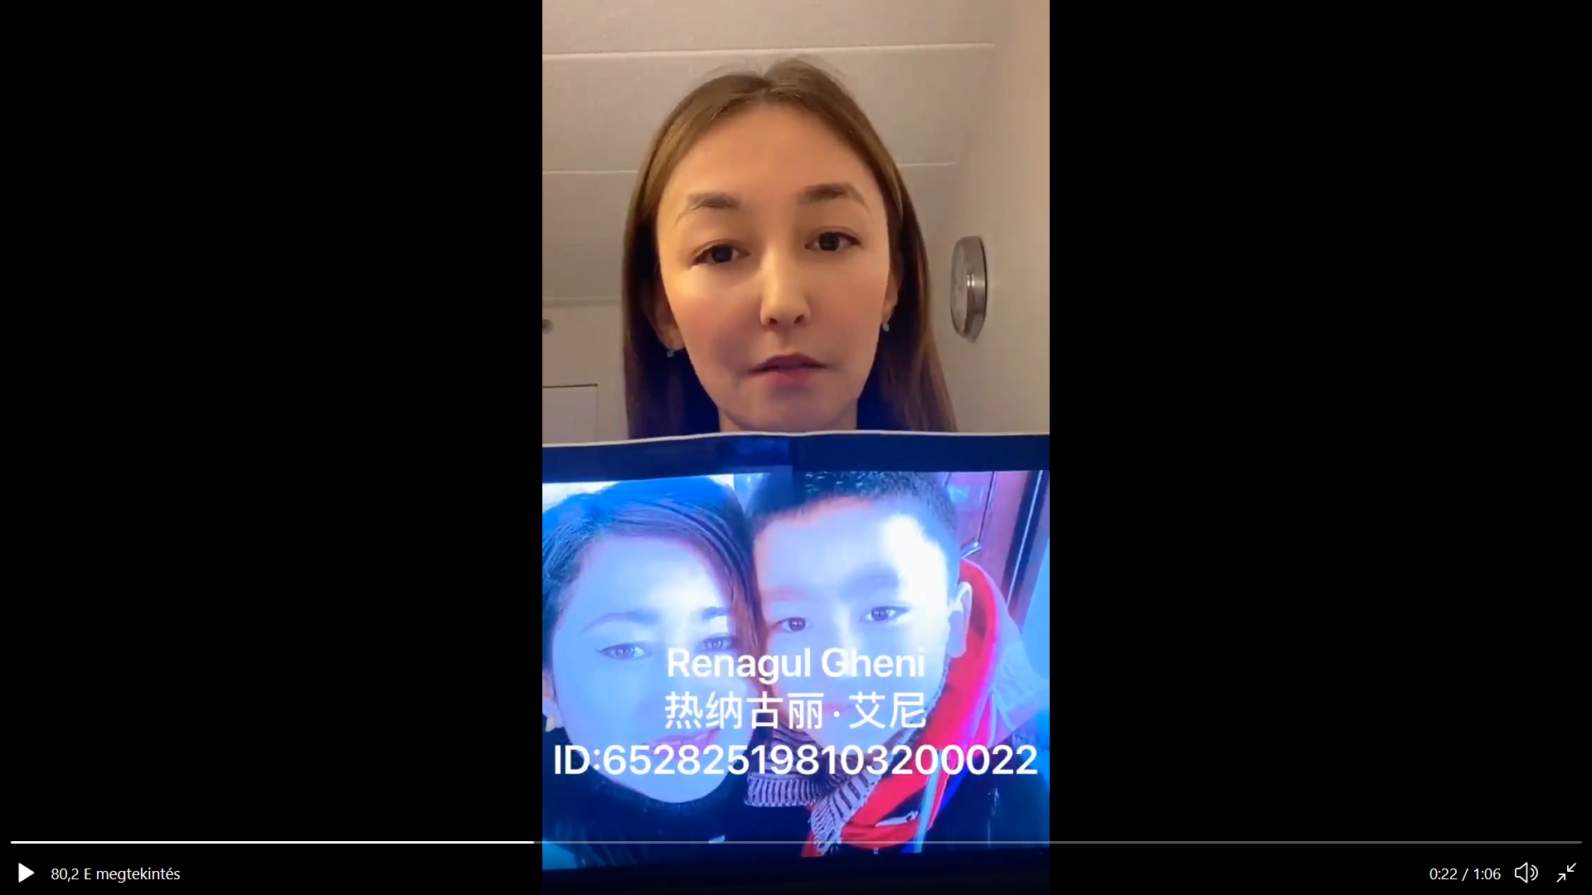

<https://twitter.com/Qelbinur10/status/1214058448310210560>

Mirehmet Ablet’s brother, his wife and their two kids were happy till aug 2017, the day he was taken away from home at night by the Chinese police in Kashgar. His crime is being a well educated young Uyghur man. They still do not know if he is in prison or concentration camp. They hope he is still alive.

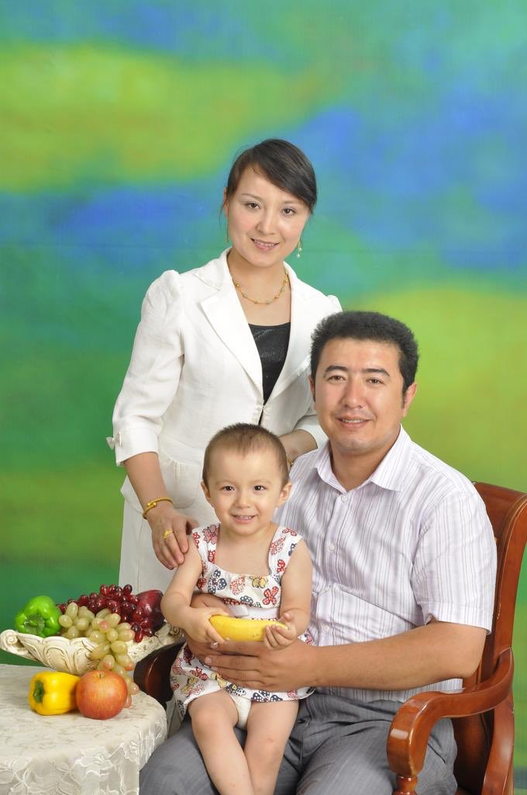

<https://twitter.com/mirehmet/status/1284126365168672771>

"Sorry the user you dialed is turned off." Since the last three years Abdurahman Öztürk has no information about his father, mother, brother, sister and relatives.

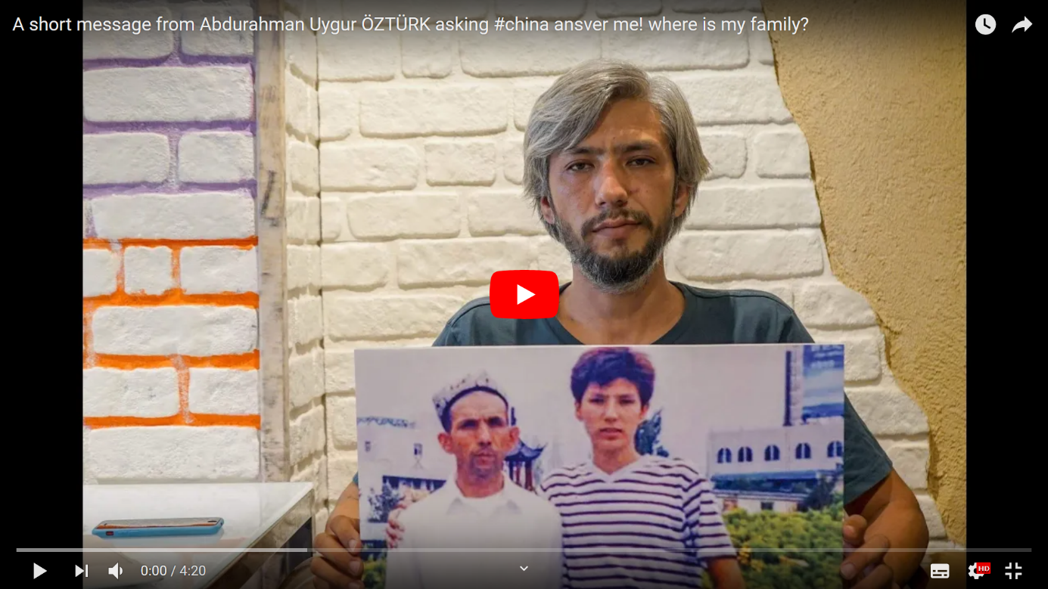

<https://www.youtube.com/watch?v=sh6W4-Jet74>

Mamutjan Abdurehim’s wife, Muherrem Ablet was taken to a camp in 2017, released two years later, but then re-detained and allegedly sentenced. He cannot talk to his two young children since 2017.

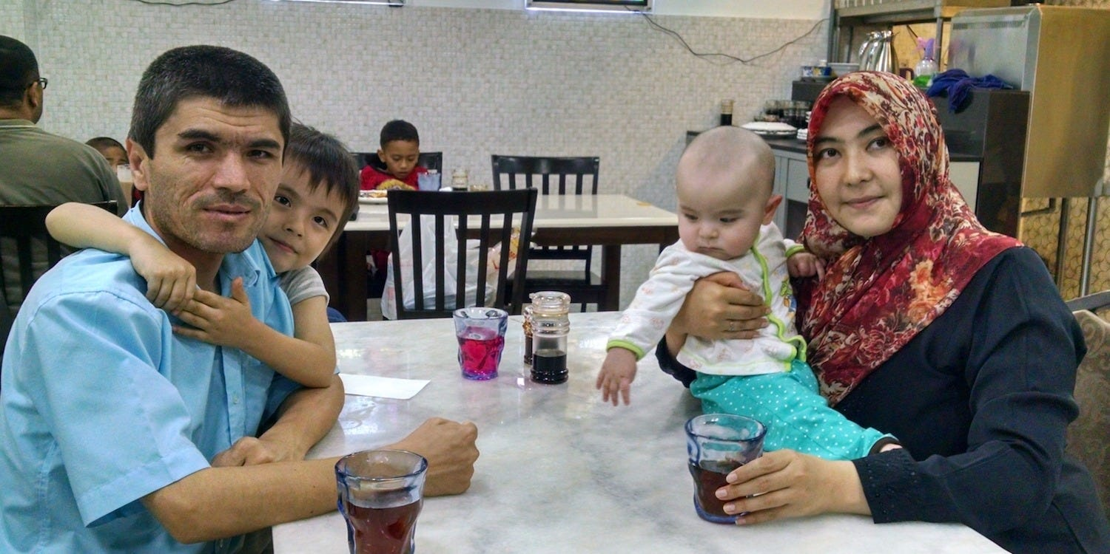

<https://www.businessinsider.com.au/uighur-china-father-mamutjan-abdurehim-wife-detained-ordeal-2020-7>

Shayida Ali’s father, Elijan Mamut, an educated Uyghur business dissapeared in 2017. She has not heard from him for three years.

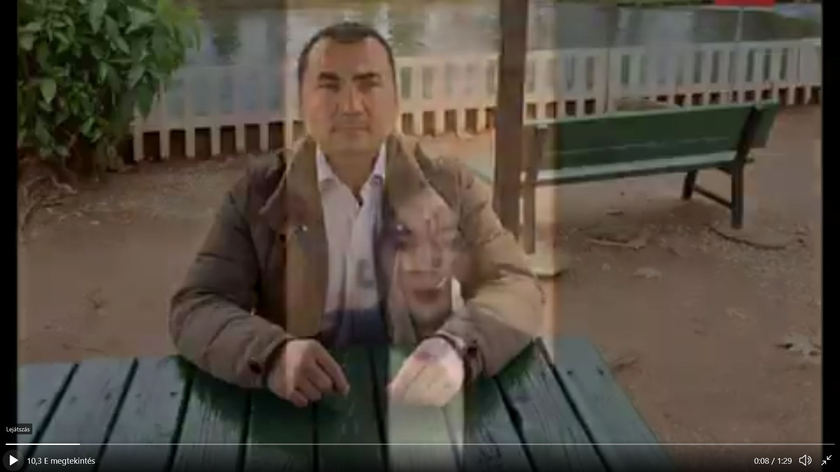

<https://twitter.com/sydaaaAli/status/1261313250890846209>

Since 3 YEARS Arfat Erkin has still no information about where his father is, or even if he is still alive.

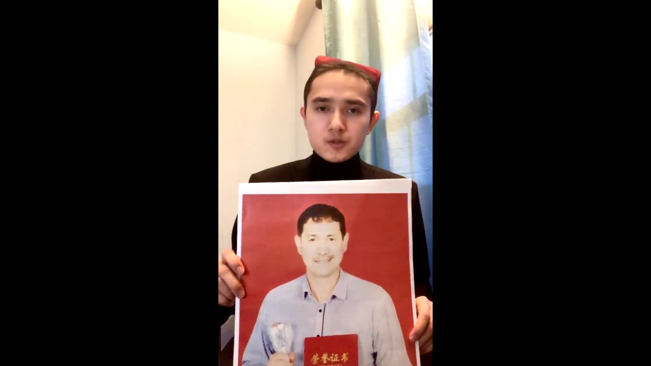

<https://twitter.com/Alfred_Uyghur/status/1346946379705413632>

**The goals**

From official documents we know that the Chinese goverment applies the means of concentration camps as a forceful measure in order to destroy the Uyghur identity (aka „extremism”). Concentration camps are designed to

* forcibly prevent large Uyghur families
* forcibly prevent religious practicies
* forcibly prevent pass on of Uyghur identity to minors
* forcibly prevent free opinion and speech

According to the 2019 white paper, „Vocational Education and Training in Xinjiang” issued by The State Council Information Office of the People's Republic of China:

"Addressing both the symptoms and root causes and integrating preventative measures and a forceful response Xinjiang has established vocational education and training centers in accordance with the law to prevent the breeding and spread of terrorism and religious extremism."

<https://www.fmprc.gov.cn/ce/cegv/eng/zywjyjh/t1692588.htm>

See also the Uyghur Pulse Youtube channel which has over 1000 video testimonies:

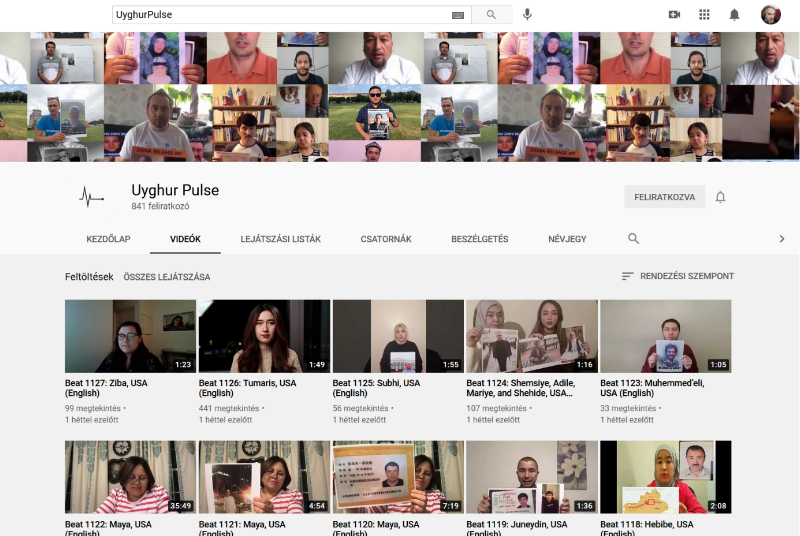

<https://www.youtube.com/channel/UCxtHBfWaWYQPNgfvdvSDn4A>